Challenges with docker-compose: SPF (Not suitable for production environment) - Failover*
How to assign dynamic ports of the container to the LB.
Every container has its own unique IP address and every container get its individual port number, in order to do load balancing it’s a challenge that whenever we redeploy the containers the port number will get changed.
It is helping us to make a multiple container from the same image, if we create 4 containers then each container gets individual port number, if we want to send a request to all containers then we must have a load balancer but what happens if we restart my container? The port number gets changed? How we manage this dynamic nature of the containers?
Compose utility is creating multiple containers in the same node, what happens if my node goes down?
We are creating multiple containers for HA, but what will happen if my node goes down? Will I get the HA? No, its SPF.
It’s helpful in development but not recommended for production environment.
It provides feature of multiple replicas and scale up and scale down only.
How to manage dynamic nature of container (port change)?
Docker Swarm
How to run multiple containers from single/multiple images, into multiple VMs with a single command?
In production env maintain multiple servers.
solution: container orchestration
- docker swarm
- kubernetes
Limitation: As of now we have discussed the networking within the same host, which is not a realistic scenario.

How containers communicate across different node?
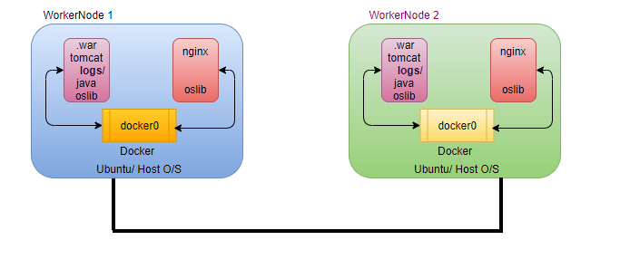
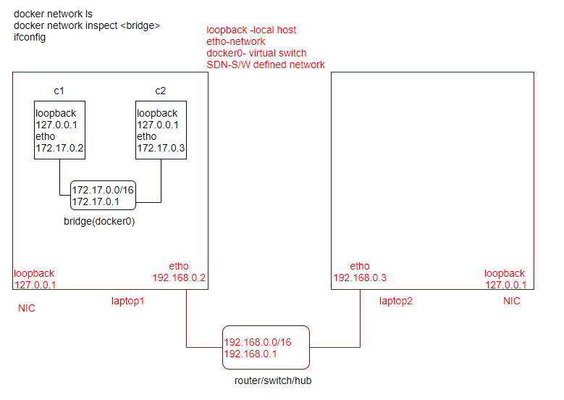
By default, nodes are able to communicate to each other through the underlay network (AWS, GCP)

Docker Swarm
- How to run multiple containers from given image into multiple vm/server/ec2?
- How to manage dynamic nature of the containers?
Ans: We need an automation (Container Orchestration)
  - helps you to deploy the container into multiple servers
  - manage the containers across the multiple servers
  - provides various benefits.
    - Desired State
    - Scale-up/ Scale-down
    - request route to container (dynamic nature of container)
Cluster? Group of servers/ multiple servers
Container Orchestration tools?
- Docker Swarm (5%)
- Kubernetes(K8s)-95%
docker swarm cluster?
docker -v
docker info # swarm by default inactive
docker swarm init # vm/server act as a master
docker swarm join # worker node (vm/server will start reporting the master vm)
docker node ls # in master node
docker node inspect <node name>
docker node ps enode01
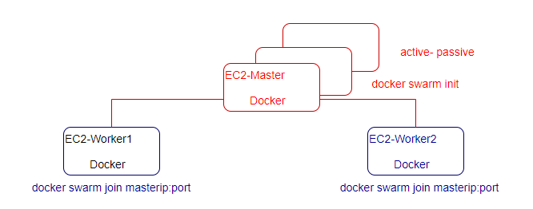
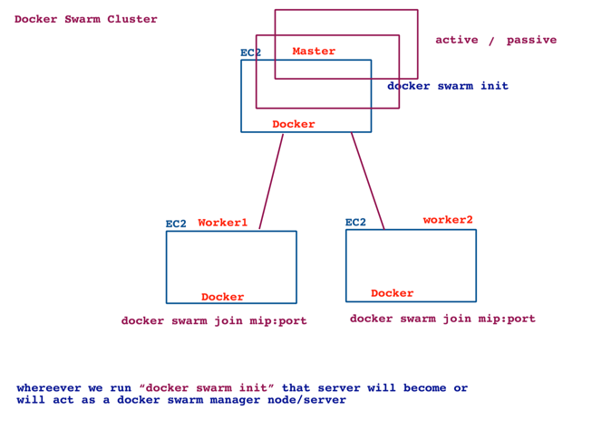
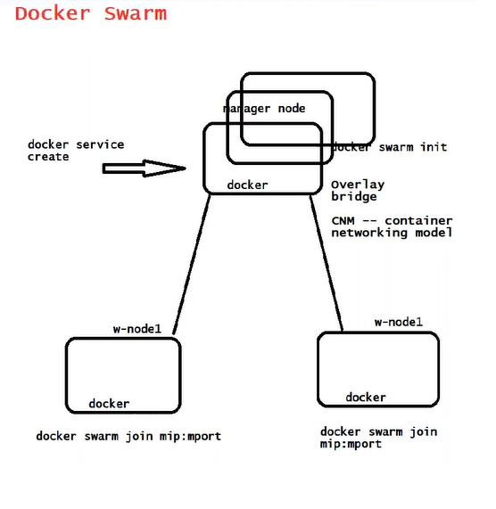
docker swarm capability is by default inbuilt with docker, which is by default inactive state, we activate the same using the command docker swarm init
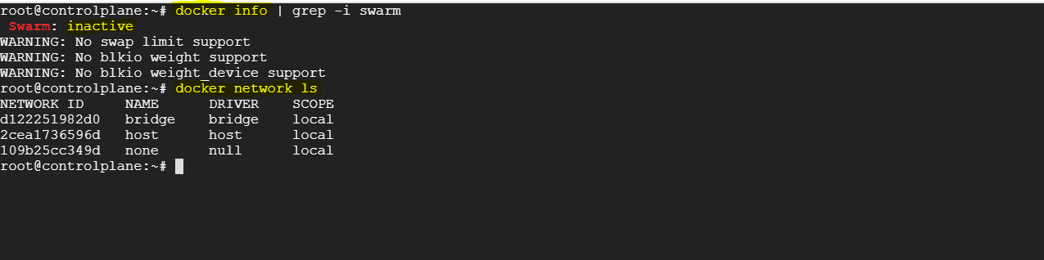
How to activate the swarm?
docker swarm init
# Wherever we run “docker swarm init” that server become or will act as a docker swarm manager node/server.
As we initialize a docker swarm, docker creates a new extra network which span across the cluster, when you join the multiple docker hosts on the single cluster, docker joins the multiple docker host in single virtual network again as an overlay network.
In master node
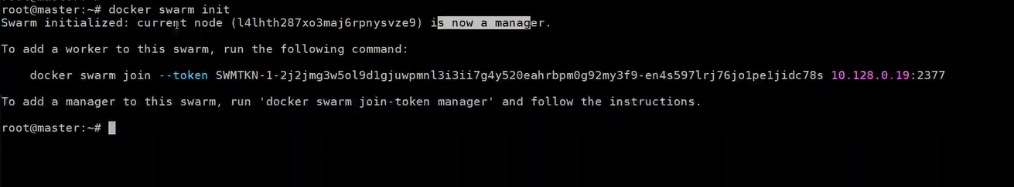
In worker node
In master
docker node ls
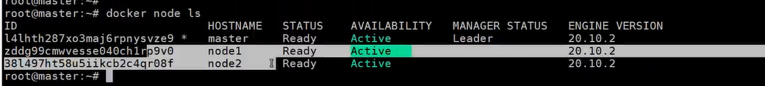
How to deploy multiple containers together?
group of VMs-> cluster
group of containers-> service
How to deploy multiple containers (service)?
docker service create --name myapp –replicas=7 -p 9000:3000 lerndevops/samplepyapp:v1
docker service ls
docker service ps myapp # details cluster level command
docker ps # local command
docker service scale myapp=15
docker service scale myapp=2
How to access container from browser
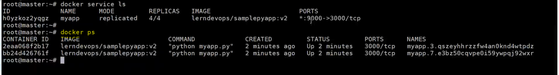
We expose the port number for the service, not for the container.
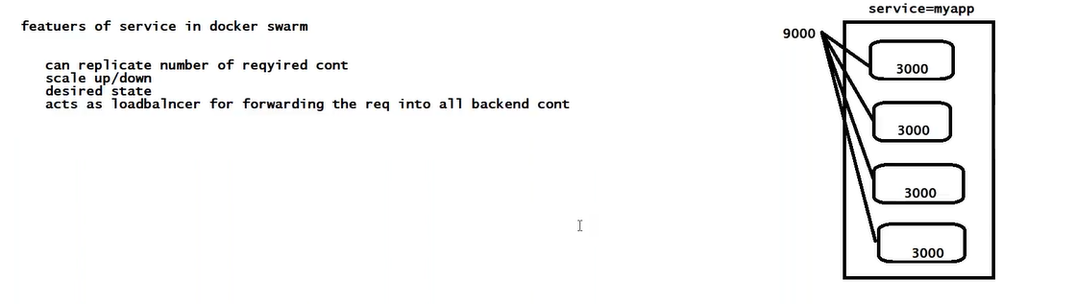
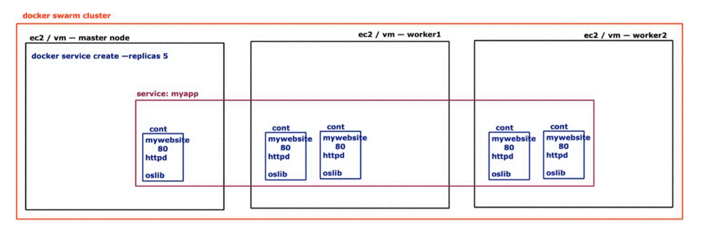
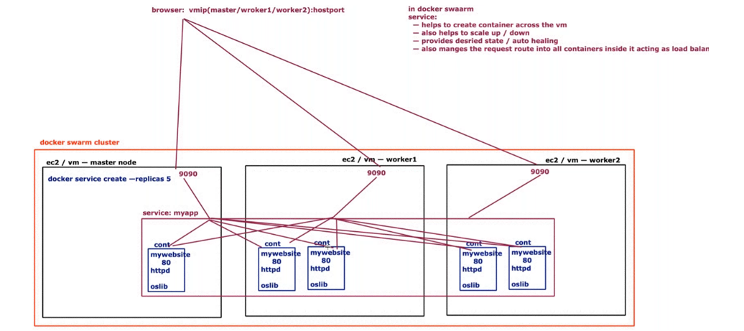
Features of service in docker-swarm
- Can replicate required number of containers
- Scaleup/down
- Cluster HA
- Auto healing (desired number of replicas)
- Act as a LB for forwarding the request into all backend containers.

docker service --help
docker service inspect <name>
docker service logs <name>
docker service rm <name>
docker service create --help
UC: How to create multiple service with single command
docker-compose (stack)
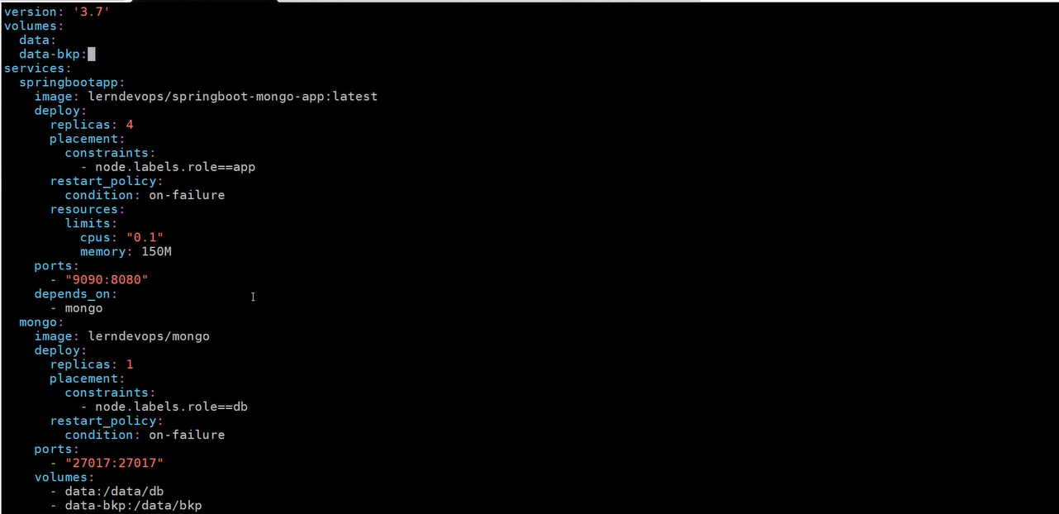
UC: want to schedule container on specific node.
placement:
constraint:
node.labels.role==app
How to execute a docker compose file in docker swarm?
In case of docker-swarm, docker-compose creates stacks (group of services)
docker stack deploy -c mycompose. yaml <name of stack>
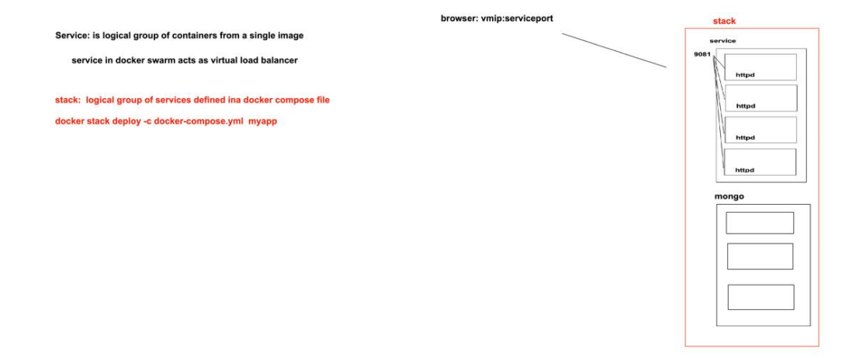

docker stack deploy -c mycompose.yaml myappstack
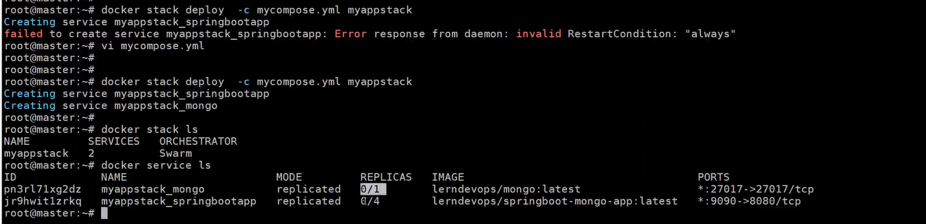
Why services are not scheduled?
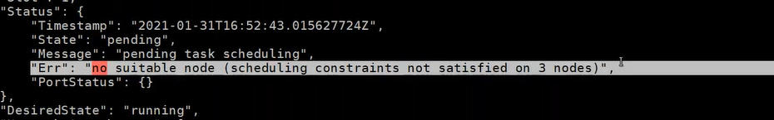
How to update the node labels?
docker node update --label-add role=app node01
docker node update --label-add role=db node02
docker node inspect node01
docker node inspect node02
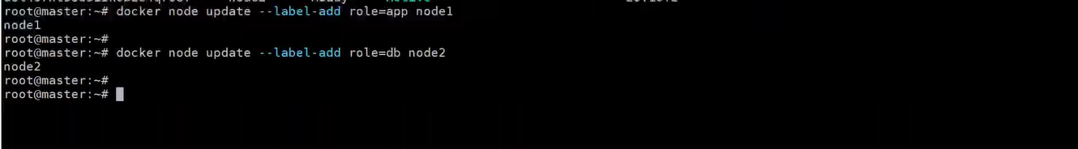
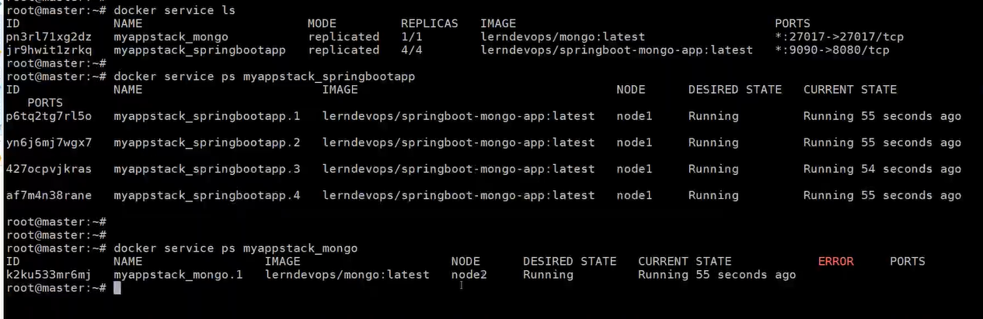
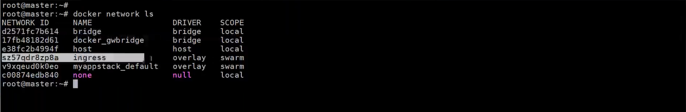
Limitation:
- don’t provide autoscale.
- support only docker
- Container Network Model
- don’t support Helm
- RBAC (in-built security)
De-cluster docker swarm
- delete all the services from master node
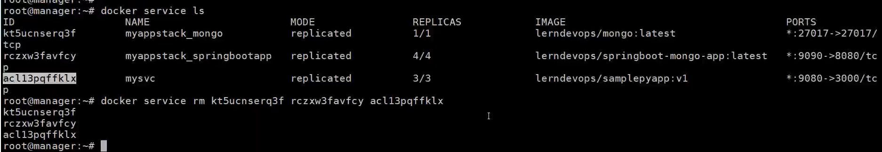
- docker swarm leave –f //in worker nodes.
First inactivate the docker swarm before installing K8s.
Difference between docker swarm and K8s?


